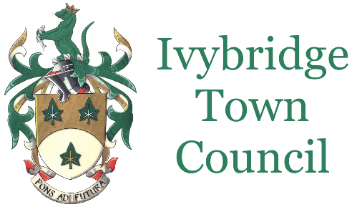
Youth Grant Application Form – Applications close 7 October 2022

Ivybridge Town Council has a fund of £4600 to invest in activities for young people who live within the parish of Ivybridge Town Council.
The Town Council would like to see new and additional activities, ideally with a strong youth work element to help support young people’s mental and social wellbeing, as well as provide a fun activity for them to take part in.
The Council is looking to find as wide range of activities as possible.
Funding will be granted for:
- Delivery of the activity
- Costs of room hire, equipment hire or purchase, and people to deliver the activity
Funding won’t be granted for:
- Activity that has already happened
- Activity that is selective of which young people can access it (see below)
- Individuals
- Organisations that do not have a Health and Safety Policy, Insurance, and Safeguarding Policy (free or reduced price Safeguarding training is available and can be funded)
- Indirect overheads (eg organisation administration etc)
Decision Criteria:
Priority will be given for applications that are
- New or additional activity
- Open to all – although activity that is selective to address an imbalance of current activity will be considered
- Value for money – a per head calculation (total funding divided by max possible number of young people that can participate)
- Free of cost to the young person – although low cost activities will be considered

Application:
Name of Group/Organisation
Named individual as main contact
Address
Email address
Contact number

Total Cost of Activity
Total Grant Requested from Town Council (maximum £2300)
Details of other funding sources secured to make up balance

Age range of young people who will access the activity

Number of times (sessions) that the activity will take place (Note that all activity must take place between notification of successful grant application and 31/03/2023)

Capacity (number of unique young people that will be able to access the activity)

= Number of sessions x number of places at session

Grant per young person

= Total Town Council Grant requested divided by (Number of sessions x capacity)

How will you ensure only young people who live in the Ivybridge Town Council area will benefit from this funding?

Where will the activity take place?

Cost to young people to access the activity (activity free to the young person preferred)

Please describe your proposal below, including how the grant will be spent – you may supply an additional document if you prefer.

Do you agree to any reasonable reporting requests from Ivybridge Town Council on how the grant was used including financial auditing.
Do you agree to use the Town Council logo and the wording ‘Supported by Ivybridge Town Council’ in any promotional material and social media/online activity.
Can you confirm that you have a Health and Safety Policy, Insurance, or Safeguarding Policy (free or reduced price Safeguarding training is available and can be funded)
Would you be willing to accept a reduced grant from the Town Council, and if so are you confident you could find the remaining shortfall, or would you discuss a scaled back proposal with the Town Council

Signed (named main contact individual)
Date

Please sent your application by post to the Town Hall, Erme Court, Leonards Road, Ivybridge, PL21 0SZ or to townclerk@ivybridge.gov.uk to arrive by 7 October 2022.

